Android Service Tutorial

**Android service** is a component that is *used to perform operations on the background* such as playing music, handle network transactions, interacting content providers etc. It doesn't has any UI (user interface).

The service runs in the background indefinitely even if application is destroyed.

Moreover, service can be bounded by a component to perform interactivity and inter process communication (IPC).

The android.app.Service is subclass of ContextWrapper class.

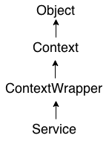

## **Life Cycle of Android Service**

There can be two forms of a service.The lifecycle of service can follow two different paths: started or bound.

1. Started
2. Bound

#### **1) Started Service**

A service is started when component (like activity) calls **startService()** method, now it runs in the background indefinitely. It is stopped by **stopService()** method. The service can stop itself by calling the **stopSelf()** method.

#### **2) Bound Service**

A service is bound when another component (e.g. client) calls **bindService()** method. The client can unbind the service by calling the **unbindService()** method.

The service cannot be stopped until all clients unbind the service.

